**CURRICULUM VITAE**

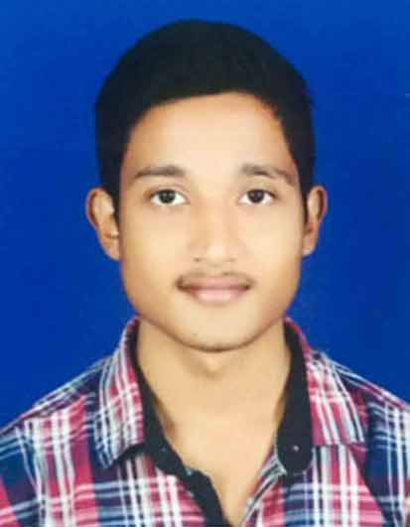

**BISWAJIT PRADHAN**

**:**biswajitpradhan120@gmail.com

**               :** **+91** 9937816787

________________________________________________________________

***Career Objectives:***

Aspiring for a responsible position in the Industry where my educational skills and practical experience could be utilized to the full extent and in the process which will help me in augmenting my skills to new degrees of competency challenges and persistence career growth.

***Educational Qualification:***

|  |  |  |
| --- | --- | --- |
| **Examination Passed** | **Name of Institution/Univeristy** | **Year of Passing** |
| **10th** | **B.B. High School, Dhenkanal** | **2012** |
| **+2** | **Regional College Hindol, Dhenkanal** | **2014** |
| **+3** | **S.S.S Mahavidyalaya Gaudakateni, Dhenkanal** | **2017** |

***Additional Qualification:***

* ***PGDCA***
* ***OS CIT***

***Technical Proficiencies:***

* Operating System : Windows - XP/Vista/Windows 7/8.1/10
* Language : C/C++/java/.Net/PYTHON
* Application : MS Office
* Typing : English, Hindi, Odia

***Personal Profile:***

Father Name : Rudranaraya Pradhan

Mothers Name : Rasmita Pradhan

Date of Birth : 26.04.1997

Languages Known : English, Hindi, and Oriya

***Permanent Address:***

At-Brahmapur

Po-Bedapada

Ps-Rasol

Dist-Dhenkanal

Pin-759019

***Strength:***

Quick Learner, Good listener & Can adapt with any kind of Environment.

Place: **Biswajit Pradhan**

Date: (Name)